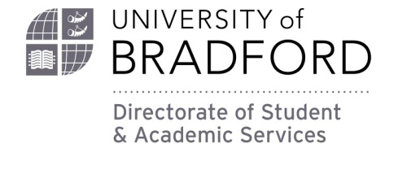

Baroness Lockwood Memorial Scholarship Trust
Available to current female students within the faculty of Engineering and Informatics.
Closing Date: Friday 1 April 2022 (late applications will not be considered)
If you do not fully complete this form, or fail to submit any required documents, your application for a Scholarship may not be considered.
About You:
Mrs Miss Ms Other
First name(s)
Surname
Date of Birth
Nationality
Home Address

Mobile Number
Email Address

Academic Details
Course Title
University of Bradford Student Number
Area of application – Please tick which category of award you’re applying for:
Hardship………….
Star Student……
Hardship – Give examples of hardship to remain on the course – or unforeseen circumstances that have led to hardship.
Star Student – Give examples of outstanding academic achievement or improvement. Could also be course-related contribution.
- In no more than 500 words, please inform why you feel that you should be awarded the Scholarship. Dependent on whether you’re applying as Star or Hardship, please give examples. For Star Student, you could example academic achievement or improvement. For hardship, you could detail financial difficulties and how you’ve been able to manage this in order to continue on your course.

Please note that this is a competitive application process, so not every application will be successful. If you haven’t heard from the University after the closing date (1 April 2022), please assume that you have been unsuccessful.

Declaration
I declare that all the information I have supplied in this application is correct. If I am found to have submitted false information I understand that my application and/or any scholarship award will be discontinued immediately.
If I am awarded a Scholarship I give my consent for my profile to be featured on the University’s website and in other materials e.g. the prospectus.
Signed ………………………………………………………………………………………………………………………………………………………….
(you may type your name above)
Date ……………………………………………………………………………………………………
Please send this form to: scholarships@bradford.ac.uk
The deadline for this submission is Friday 1 April 2022

